

Project Plan

# Project assignment

## Context

Funded by the company Jupiter, new hardware store Media Bazaar is opening their first shop in Eindhoven. So far, Jupiter’s administration has had a lot of trouble managing the administration of their employees and stock.

The administration has difficulty tracking the amount of hours the employees have worked and the salary of said workers. At other Jupiter stores, the shifts are currently assigned by the manager who keeps track of every worker in Excel sheets or online calendars. However this system is unreliable and prone to mistakes, which can result in multiple employees not showing up for their assigned shift.

The stock management, on the other hand, is not stored in the most efficient way, so improvements are expected to be made on that part too.

The company expects a software solution which will help with both their employees and their products administration.

## Goal of the project

The goal of this project is to simplify both the store's operations and the company's administrative tasks, while also eliminating any confusion arising from employee scheduling. The primary focus of our initiative is to develop an IT solution that will put an end to misunderstandings or ambiguities among the workforce.

## 

## 

## 

## 

## Scope and preconditions

| **Inside scope:** | **Outside scope:** |
| --- | --- |
| 1. Develop a comprehensive software solution for tracking employee work hours and scheduling. This includes features like shift assignment, and leave management. | 1. The project does not include the procurement or management of physical hardware such as computers, servers, or barcode scanners. |
| 1. Implement an efficient inventory management system to track products, monitor stock levels, and optimize inventory ordering and restocking processes. | 1. Marketing strategies and promotional activities for Media Bazaar's products are not within the project's scope. |
| 3 Create user roles and permissions to ensure that only authorized personnel can access specific parts of the system, maintaining data security. | 3 Redesigning the physical layout of the store is outside the scope of this project. |

## Strategy

We will approach this project by using the waterfall model. This is, starting with gathering the requirements and necessary information from the client, which will be the base we build our system design on. Followed by implementation, testing and finally delivery of the final product.

## 

Project breakdown structure

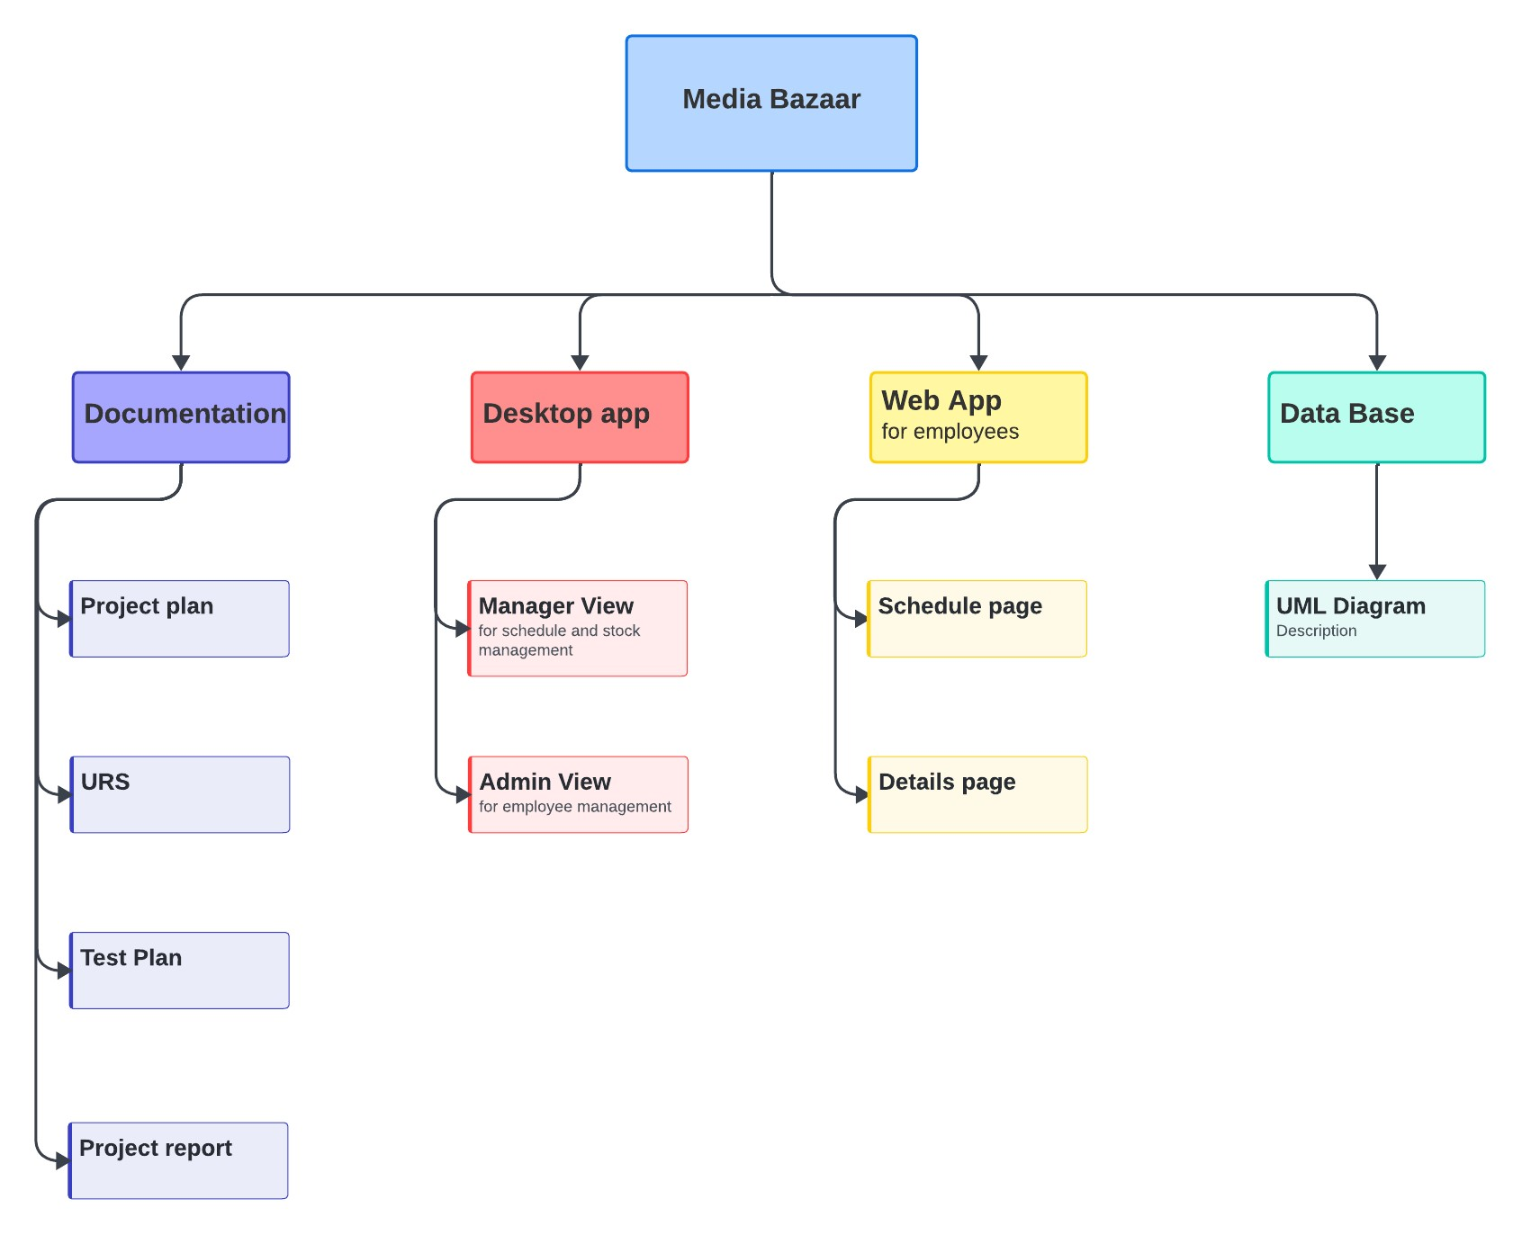

# Deliverables

| Activity name | Multiple documentation files |
| --- | --- |
| Input | Research and concept creation |
| Description of the activity | Ideation, project plan, URS, test plan |
| Output | Complete understanding of the project, the stages it went through and what it consists of |

| Activity name | Desktop application (intended for administration and management) |
| --- | --- |
| Input | As an administrator: managing employee registrations  As a manager: scheduling and checking stock. |
| Description of the activity | As an administrator: adding/ removing employees, entering/ modifying employee details, registering sick leaves  As a manager: schedules employees on the employees availability and checks and restock the product stock |
| Output | As an administrator: the new employee will get an email with their temporary password. The admin can approve or disapprove the sick leave  As a manager: the employees can see their schedule on the website. Where does the stock go? |

| **MoSCoW Chart (Desktop application)** | |
| --- | --- |
| **Must have**     * Login * Online database * Adding/ deleting employees (Admin) * Employee schedule (manager) * Managing employee attendance * Statistics about employees | **Should have**     * Keeping track of stock * Re-stocking from the depot |
| **Could have**     * Automated scheduling | **Will not have**     * Manual (how to use) * No register page for the admin * No register page for the manager |

| **MoSCoW Chart (Web application)** | |
| --- | --- |
| **Must have**     * Login * Viewing schedule * Calling in sick * Editing contact details | **Should have** |
| **Could have**   * Clock-in/ clock-out | **Will not have**   * Manual (how to use) * Registration for employees |

# Non-Deliverables

| Activity name | Manual |
| --- | --- |
| Description | A manual of how to use the website |
| Why not? | I want to make the applications UX and UI friendly |

# Project organization

## Stakeholders and team members

Our client is Media Bazaar, a new hardware retail outlet financially backed by the Jupiter corporation. Sachin Bhardwaj serves as the company's representative.

The software team consists of five members:

* Uraela Mamo
* Murat Zünbül
* Leon Pişta
* Valentina Nogales
* Cătălin Popoiu

| Name | Role and functions | Availability |
| --- | --- | --- |
| Sachin Bhardwaj | Representative of Media Bazaar | Every Tuesday, throughout the whole project |
| Uraela Mamo | Developer | Every Tuesday and Wednesday, throughout the whole project |
| Murat Zünbül | Developer | Every Tuesday and Wednesday, throughout the whole project |
| Leon Pişta | Developer | Every Tuesday and Wednesday, throughout the whole project |
| Valentina Nogales | Developer | Every Tuesday and Wednesday, throughout the whole project |
| Cătălin Popoiu | Developer | Every Tuesday and Wednesday, throughout the whole project |

As a team we have decided not to declare one single team leader but rather to take turns in this role so that everyone can gain experience from this position. We will have a weekly rotation of the role.

## Communication

A meeting between Koala Code and the client will take place either on Tuesday or Thursday every few weeks to discuss the progress made and any possible changes or setbacks the team might be facing.

The team is responsible for providing an agenda for each meeting and documenting everything that is discussed during the meeting. An invitation will be sent out to the client weekly.

Other than that, both parties will be reachable via email.

Internal communication within the software team will happen through Discord and WhatsApp. We will also use Trello in order to keep track of our progress and task division.

## **Risk management**

The risk analysis is done to make some agreements on how to negate the risks before you start the project. The risks described are threats to the success of the project. For larger projects these will include some typical project-related risks. Within the project, we have defined the following possible risks that can happen throughout the project:

1. **Miscommunication between team members:** Whenever we work together, there are chances of misunderstanding things which can lead to major loss in the progress of our work. It can happen when someone fails to understand something somebody said, or people do not attend meetings which leads to the transfer of false and misleading information.

2. **Inaccurate expectations:** Though we decide to deliver according to client’s demand, there can be slight or moderate differences in the final product which the client may or may not like because of the way we have interpreted the client’s needs/demands.

3. **Improper planning:** As we know that to achieve a result in our desired way, proper planning is required. Similarly, in a group project creating and following a proper plan is one of the important things. If the planning is not good enough or not followed properly then it is ideal to face hurdles, and which further leads to massive consequences.

4. **Delays:** Several times it happens that while doing some work we don’t understand how to move ahead on a problem, and we get stuck. This leads to delays in accomplishing the desired goals. Similarly, as above-mentioned improper planning can also lead to delays in completion of the work because not following the plan and doing random things will make the work more difficult to complete on time.

5. **Loss of work while using GIT:** In some cases, it happens when we are working on the same branch in GIT, one person must wait until the other member pushes their work. If someone is working on their work and pulls other work then his/her work will be lost, and this can affect the progress of the project and can cause delays in the finalization of the project as mentioned above.

6. **Opinions discrepancy:** Mismatch of the opinions is an ideal case which can happen while working in a team or group. This can have a little bit or sometimes a massive impact on the behavior of an individual of the group and the way of working may be disturbed.

| **Risk** | **Probability** | **Impact** | **Possible Solution** |
| --- | --- | --- | --- |
| 1 | Likely | Extremely harmful | By attending meetings and asking the required questions if one cannot understand something. |
| 2 | Likely | Extremely harmful | Between student and teacher clear discussion about the quality and expectations of the clients should be discussed. |
| 3 | Unlikely | Harmful | Proper planning must be made before starting the project and should be followed strictly. |
| 4 | Likely | Harmful | Following the Gantt chart and help someone if anyone gets stuck in their part of work. |
| 5 | Unlikely | Harmful | Work on different branches |
| 6 | Likely | Harmful | Respect each other's opinion and make a collective decision about some kind of implementation. |

## 

## Phases of the project

During this project we have 2 phases: the waterfall phase and the iterative phase.

| Phases | Deliverables | Milestones | Weeks |
| --- | --- | --- | --- |
| Phase 1: Planning and analysis | * Team Name and Team Logo * Questions for Client * Create Meeting Minutes * Project Plan * URS * Wireframe | Finish off all the necessary documents  * Finish wireframe | Week 1-3 |
| Phase 2: Development | * Database * *Website pages* * Windows Forms app | * Authentication system * Employee management functionality * Stock management functionality | Week 3 - 6 |
| Phase 3: Testing and quality assurance | * Test plan * Test report | * Testing process completed |  |
| Phase 4: Deployment and maintenance | * Project report * Finished product * Work on presentation * Check GIT repository | * Functional product |  |

## Time plan and milestones